OT Overview Devotions Week 18: Isaiah 9:1-7; 11:1-16; 25:1-9; 40:1-5

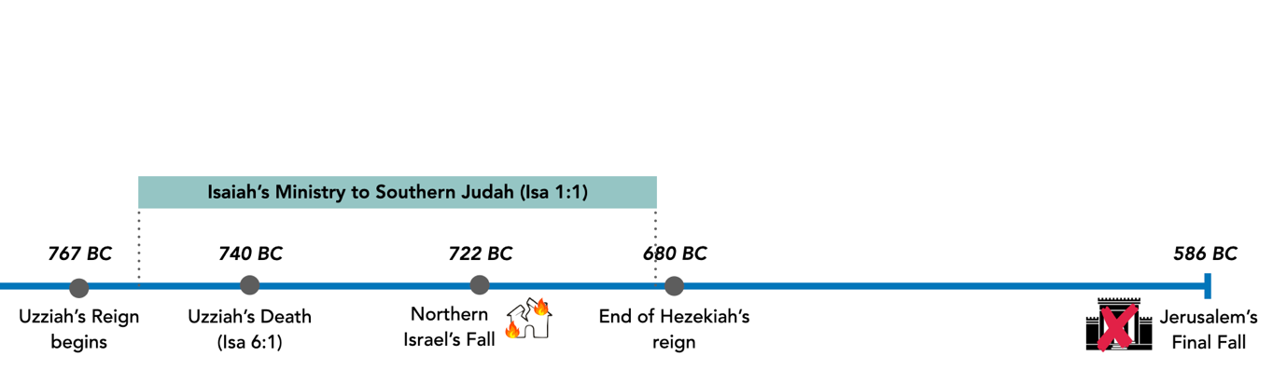

From Isaiah 1:1 and other narrative events in Isaiah, Southern Judah heard his prophecies almost 100 years before the temple destruction in 586BC. As we read Isaiah this week, pay particular attention to when Isaiah’s prophecies are fulfilled. Keep in mind how this might affect the way God’s people at different times might view Isaiah’s prophecies.

Day #1:

Recall where we are in the Big Picture Diagram now. We have hit absolute rock bottom. Despite that, at the ends of both 2 Kings 25 and Ezekiel 11, what does God promise? What are God’s people looking forward to now? Take time to speak to our Heavenly Father about how you feel about it.

Day #2:

Read Isaiah 9:1-7. What is the overall tone of this passage? What is this “great light” (v2) that the people have seen? What do we learn about this light?

Day #3:

Read Isaiah 11:1-16. Who is this “stump of Jesse” (v1)? How does this passage build on what we’ve already seen in Isaiah so far?

Day #4:

Read Isaiah 25:1-9. What does God promise here? What does it add to the promises we’ve seen thus far?

Consider the extent of what God has been promising. How is it different from what we’ve seen in the Overview so far? (Hint: remember the Covenants & Triangle Diagram)

Day #5:

Read Isaiah 40:1-5. What is the tone God uses to speak to his people? What else does the passage add to our picture of God’s salvation? Why is that significant?

Day #6:

Put together the pictures that we’ve seen in Isaiah. Imagine if you were Israel post-exile reading them. How would you feel as you see these promises? What will you be looking forward to?

How do these promises progress us in God’s Big Picture plan? Why do these promises matter to us as Christians today? Pray and give thanks to God for what we have seen this week!

