OT Overview Devotions Week 21: Nehemiah 1, 4-5, 8-10, 13

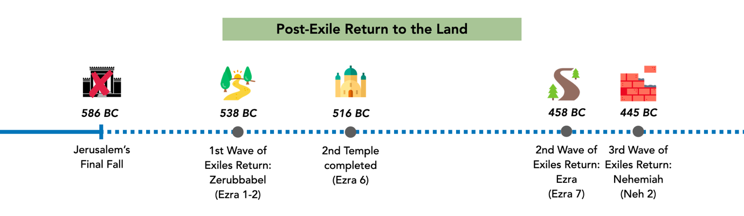
This week as we look at Nehemiah, we are seeing how God’s people return to Jerusalem after the exile. Nehemiah’s return marks the third wave of the exile. As we read through Nehemiah this week, keep in mind:
- What you learn about Nehemiah as a leader of God’s people
- The state of the people (& the city)

Day #1:

As we begin this week in Nehemiah, take time to speak to God and ask him to help us understand his Word, and how it’s relevant for us today.

Read Nehemiah 1. What does Nehemiah hear from Jerusalem and how does he respond? How do you feel about Nehemiah’s response? Why do you think he responds that way? (Consider the timeline above, and what we’ve learnt about God’s promises in the Prophets)

Day #2:

Read Nehemiah 4 & 5. What seems to be the major issues plaguing the people as they rebuild the walls? How does Nehemiah deal with these issues?

Day #3:

Read Nehemiah 8-9. How do the people respond to the reading of the Law? What about their prayer is so significant?

Day #4:

Read Nehemiah 10. What do the people agree to do in their renewed covenant? How do you feel about the people at this point?

Now, read Nehemiah 13. Compare that with what we saw the people agree to do in Nehemiah 10. How do you feel about the people now?

Day #5:

What has God’s people been looking forward to from Isaiah and Ezekiel? If you were a Jew in Nehemiah’s time, what would you be feeling right now about God and his promises? How does this reinforce what God’s people should/should not be looking forward to?

How does this help us today to appreciate God and his promises? Take time now to speak to God about how you feel about the hope we have in him!

