OT Overview Devotions Week 21: Nehemiah 1, 4-5, 8-10, 13

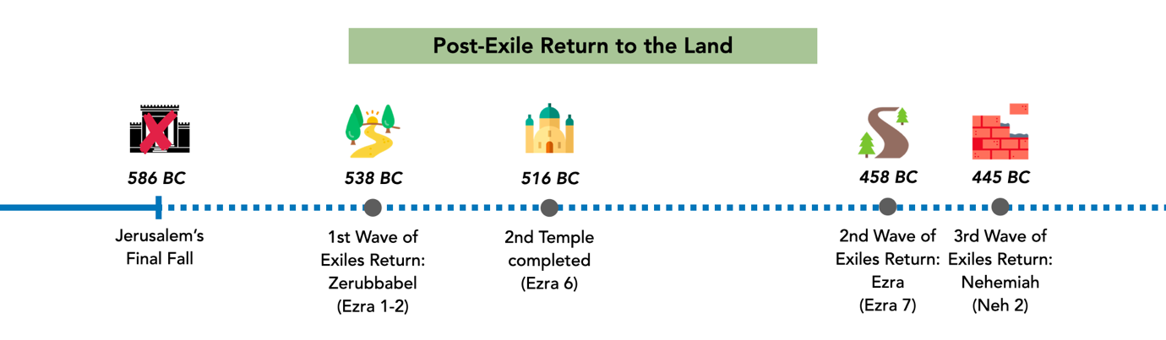
Day #1:

This week as we look at Nehemiah, we are seeing how God’s people return to Jerusalem after the exile in 586BC. Imagine if you were a Jew returning to Jerusalem in the first 2 waves. What would you be hoping and looking forward to as you journeyed back to the land? Recall what we’ve been reading about in Isaiah & Ezekiel. What might you be feeling & anticipating?

(If you have time, look at Ezra 3:12-13 – how did people react to seeing the new temple being built? Why do you think they are reacting that way?)

Take time to speak to God about these promises and hopes that you’re recalling, and how we ourselves might be longing for it today.

From Day 2 onwards, in each passage consider:
- What you learn about Nehemiah as a leader of God’s people
- The state of the people (& the city)

Day #2:

Read Nehemiah 1. What does Nehemiah hear from Jerusalem? How does he respond? What do you notice about how he prays?

Day #3:

Read Nehemiah 4 & 5. What seems to be the major issues plaguing the people as they rebuild the walls? How does Nehemiah deal with these issues?

Day #4:

Read Nehemiah 8-9. How do the people respond to the reading of the Law? What about their prayer is so significant?

Day #5:

Read Nehemiah 10. What do the people agree to do in their renewed covenant? How do you feel about the people at this point?

Now, read Nehemiah 13. Compare that with what we saw the people agree to do in Nehemiah 10. How do you feel about the people now?
Day #6:

Summarize the narrative in Nehemiah. How have you felt about the state of the people throughout the narrative? Likewise, how has your confidence in Nehemiah risen or dipped throughout the book?

Consider what God’s people would be looking forward to from Isaiah and Ezekiel (from Day #1). What would you be feeling right now about God and his promises? How does this reinforce what God’s people should/should not be looking forward to?

How does this help us today to appreciate God and his promises? Take time now to speak to God about how you feel about the hope we have in him!

