Overview #17: Ezekiel 8-10 Devotions

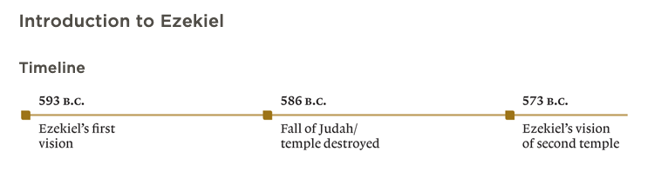
This week, we begin our time in the Prophets, starting with Ezekiel. Ezekiel was among the first wave taken into exile to Babylon along with King Jehoiachin (2 Kings 24). As we read Ezekiel 8-10, keep the events of 2 Kings 24-25 in mind and imagine what it would have been like to hear these words as exiles in Babylon.

Day #1:

Recall what happened in 2 Kings to the two key elements in God’s plan to deal with sinful humanity: the King and the House of God.

What have been your thoughts and feelings as you reflect over sin and God’s judgment on it? What has that revealed to you about God? Take a moment to speak with our Father about this.

Day #2:

As you read Ezekiel 8, list out or draw out what is happening in the temple of God using this diagram:

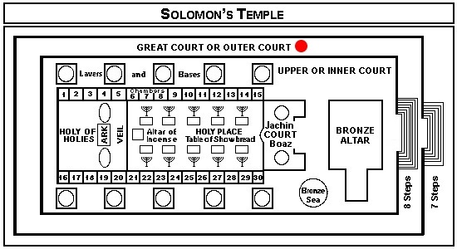

Recall generally what these parts of the temple/tabernacle were intended for by God. Who are the ones committing sin (look out for repetition that tell us about their attitudes and their actions)? What is the significance of these things taking place in these parts of the temple?

*PS: Tammuz (8:14) was a Babylonian god worshipped by ritual mourning

Day #3:

Read Ezekiel 9. Zoom in on the reason the people act so sinfully against the Lord (8:12; 9:9). Given that all this is taking place after the first wave of exiles have been deported, what is so foolish about the people’s behaviour here?

Day #4:

Read Ezekiel 10. In chapters 9-10 what different acts of judgement is God announcing? Who is to be judged? What is God’s attitude in this judgement?

Day #5:

Revisit Ezekiel 10:4; 18-19 and look at 11:22-23. What exactly is happening here? Why is this significant in light of everything God has covenanted with Abraham, Moses and David?

After this judgement and what we saw in 2 Kings 24-25, what state is Israel in? What would it have been like and feel like ‘on the ground’ in Jerusalem?

What do you think our Father wants to teach us today through this? Speak to Him about what you are feeling and thinking.

