Overview #17: Ezekiel 8-11 Devotions

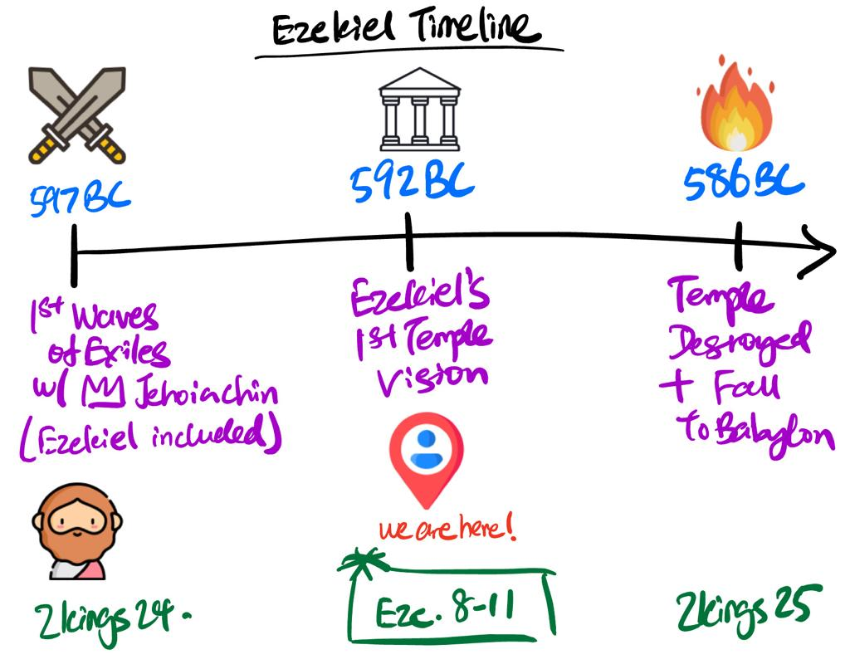

This week, we enter the time of the Prophets in our OT Overview, starting with Ezekiel. Ezekiel was among the first wave of exiles taken to Babylon along with King Jehoiachin (2 Kings 24). As we read Ezekiel 8-11, keep the events of 2 Kings 24-25 in mind and imagine what it would have been like to hear these words as exiles in Babylon.

Day #1:

In the Overview so far, sin has repeatedly been the Big Problem. Our last few weeks have introduced us to two key elements in God’s plan to deal with sinful humanity: God’s King and God’s House. Considering what happened to these two elements in 2 Kings 24-25, how bad a situation is humanity in at this point of the Overview?

What are your thoughts and feelings as you think about sin and God’s judgment on it? What have you learnt about sin generally, and what has that taught you about sin in your own life? Sin is once again the big theme of our passage this week, so spend some time speaking to God about what you’ve learnt about sin, and asking Him for a soft heart to listen to what He continues to teach us about this crucial topic.

Day #2:

As you read Ezekiel 8, locate and draw the 4 abominations that God shows Ezekiel in this temple diagram:

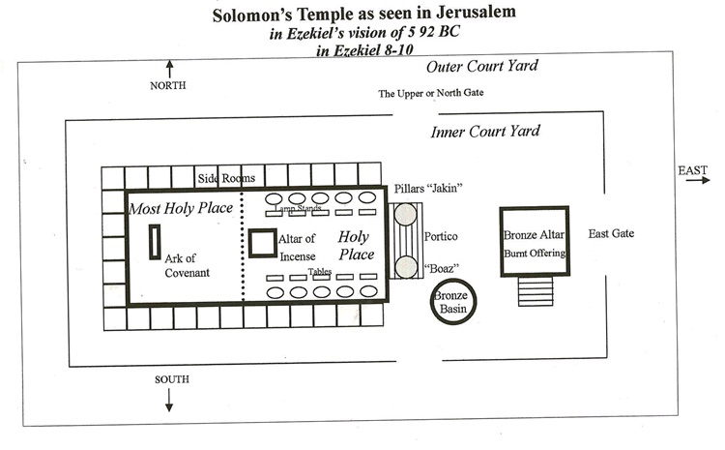

Look into the significance of these 4 things taking place in the Temple. Why are they such abominations and how would you feel if you were God seeing these things take place in His House? How does this compare to what we saw about God’s House in our 1 Kings Study?

*PS: Tammuz (8:14) was a Babylonian god worshipped by ritual mourning

Day #3:

Read Ezekiel 9. What significant event in our Overview so far does this scene of judgement remind you of? Zoom in on the reason the people act so sinfully against the Lord (8:12; 9:9). Given that all this is taking place after the first wave of exiles have been deported, what is so foolish about the people’s behaviour here?

Day #4:

Read Ezekiel 10 & the end of the vision in 11:22-25. Don’t worry too much about the more abstract details of the vision like the wheels and the faces. Focus on the big event happening (*hint: it’s something to do with the Glory of God). Why is this so devastating given the importance of God’s presence in His House from the last few weeks? How would you have felt if you were Ezekiel and the 1st wave of exiles in Babylon as you saw this chapter unfold?

Day #5:

Given what Ezekiel’s been shown since the start of the vision in Ezekiel 8, what do you feel about God’s departure from the Temple? Would you have done anything differently if you were the LORD’s position?

Now read 11:14-25. Does this remind you of anything God has said to Israel before? Why would God say these things at this point after all that’s been done in Ezekiel 8-10?

What do you think our Father wants to teach you today through Ezekiel’s vision? Speak to Him about what you are feeling and thinking. Is there anything that has personally challenged you? Is there anything that you’d like to praise God for?

