Overview #20: Ezekiel 36:16-37:28; 40:1-4; 43:1-12; 47:1-12 Devotions
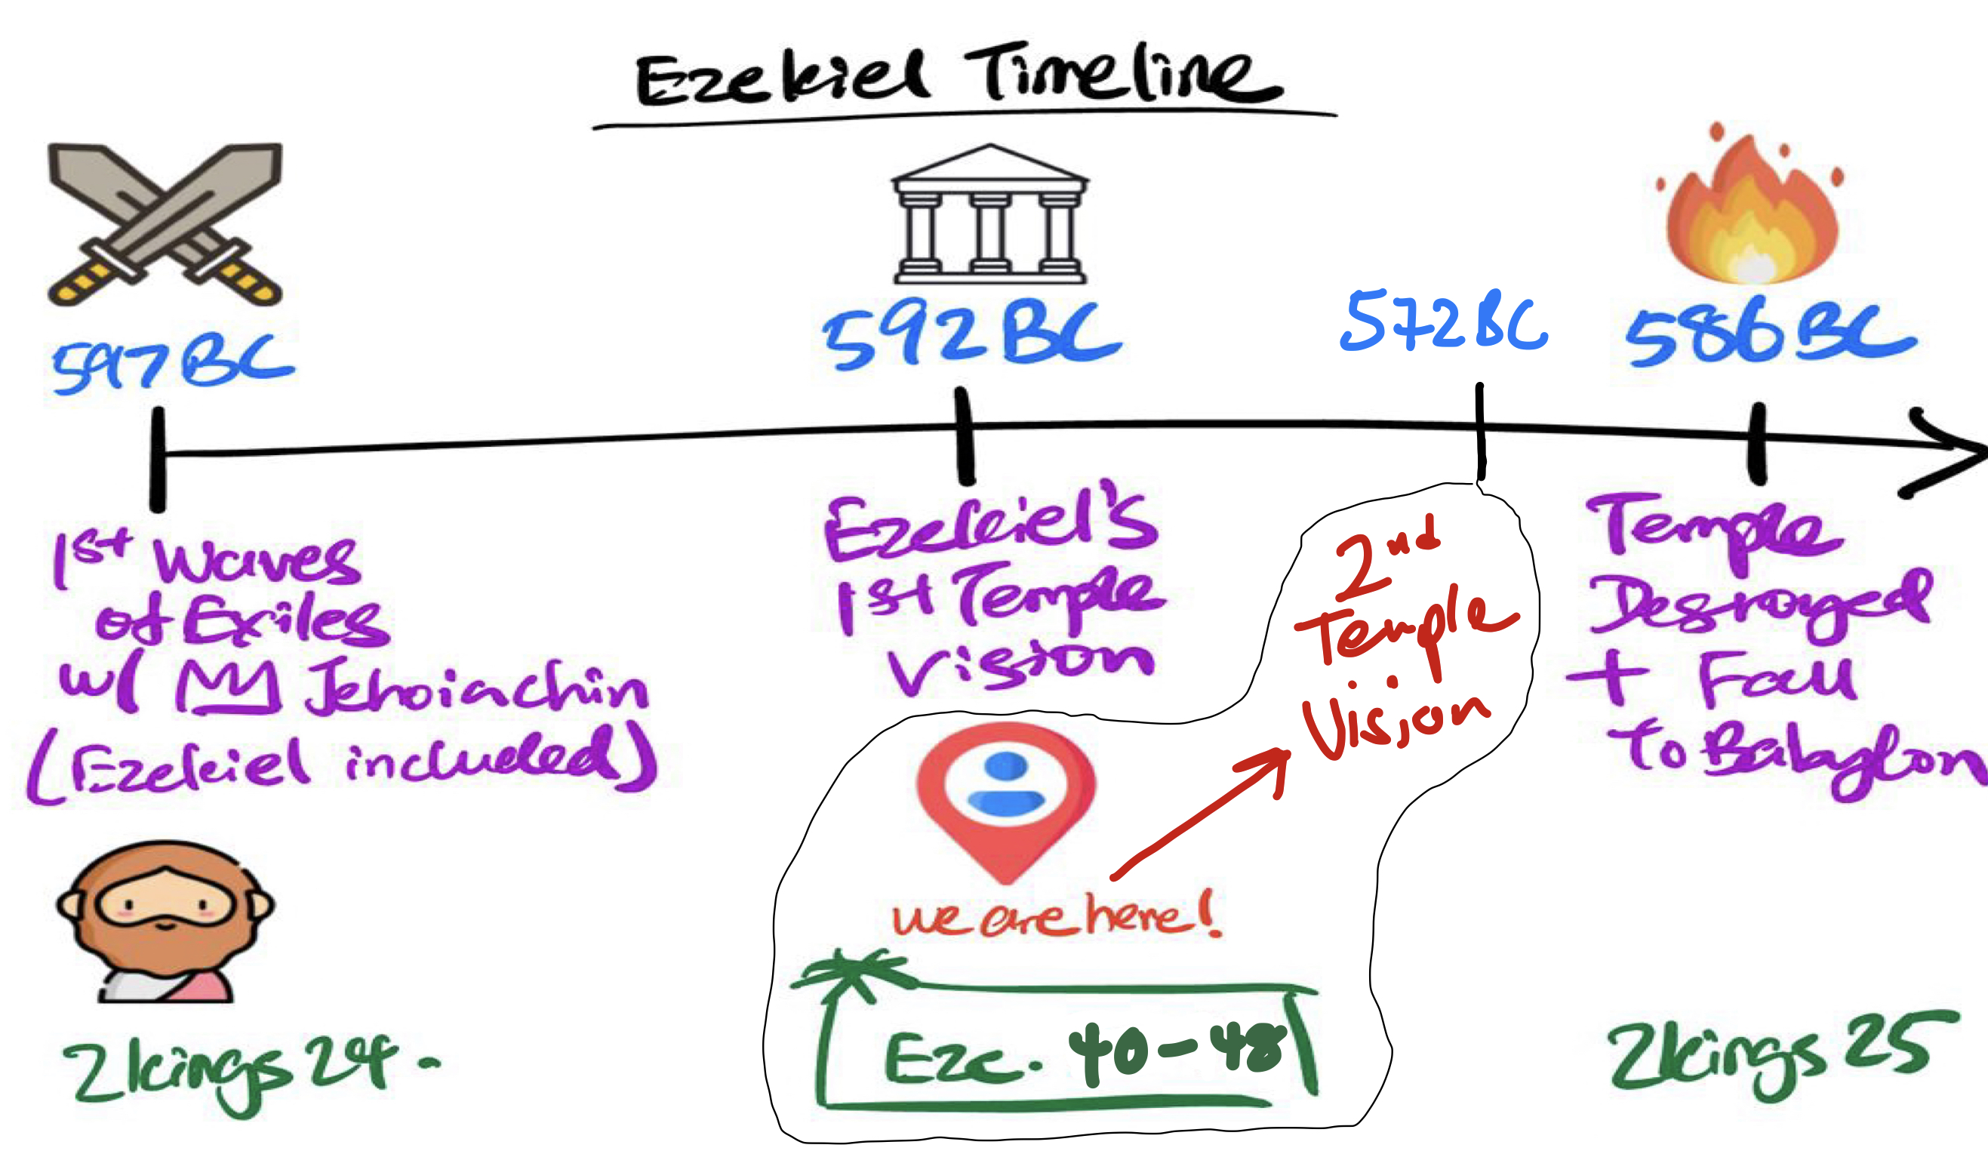

Day #1:

This week, we head back to look at the end of Ezekiel’s prophetic ministry. In order for our hearts to be affected by what God is saying in these chapters, we once again have to feel the weight of humanity’s Big Problem: our sin.

Recall what we saw in the previous temple vision in Ezekiel 8-11. What did we learn through the people’s sin, and how did it remind us of sin in our own hearts?
Meditate on the words of Isaiah 52:13 - 53:12 again, and respond to the LORD who gave Himself as this Suffering Servant. Also ask God for a soft heart to listen as He shows us even more about His Big Solution to sin this week.

Day #2:

Read Ezekiel 36:1-38. What is God saying He will do in order to deal with sin?

This passage uses the same language as Deuteronomy 30:1-10. What does Ezekiel 36:24-28 add to what God has already said through Moses in Deuteronomy 30? How do you think what is being described has been fulfilled in you as a Christian today?

Day #3:

Read Ezekiel 37:1-14. The vision of the Valley of Dry Bones is the third of Ezekiel’s four visions. What are the two things that are necessary for the dead, dry bones to come alive? How does vision help us understand God says in 36:24-28 better? [*Note: the Hebrew word ‘Ruach’ can mean spirit, wind or breath]

[Additional Thought] There seems to be a connection between this vision and what happens in the Garden of Eden (36:35). How does viewing this vision in light of Genesis 1-3 contribute to our understanding of the significance of what God is showing to Ezekiel?

Day #4:

Read Ezekiel 37:15-28. How does this now tie in what Ezekiel is saying with what we’ve been seeing in our last few studies in the Overview? In what ways do 37:22-28 tie together the great promises that God has given so far? *Hint: Think of the major covenants.

How do you feel about what God is promising here? Speak to Him about what He has said.

Day #5:

Read Ezekiel 40:1-4. Ezekiel chapters 40 - 48 recounts the fourth and final temple vision that the LORD shows Ezekiel (see diagram above).

Now read Ezekiel 43:1-12 & 47:1-12. How does this vision build on all that we’ve seen in Ezekiel so far? Referring to the diagram above, what difference does it make knowing when exactly this vision is shown to Ezekiel and Israel in exile?

How does this vision shape our expectations of the Temple that God is going to build, and why does this vision matter to us as the Church today? Close this week of devotions by speaking again to the God who is the great Builder of this Temple.

